PROGRAMMING LAB-I
ASSIGNMENT NO.4

BATCH -S7
ROLL NO -113
PRN-21510120

Q1.Create two namespaces as NMS1 and NMS2, define variable ‘a’ and function
seta() and geta () in NMS1 and define variable ‘b’ and function setb() and getb
() in NMS2. Write a program to
a. Assign and display data without using keyword.
b. Assign and display data with using keyword.
SOLUTION:-
a)
PROGRAM:-
#include<bits/stdc++.h>
using namespace std;
namespace NMS1
{
int a;
void seta(int aa)
{
a=aa;
}
int geta()
{
return a;
}
}
namespace NMS2
{
string b;
void setb(string bb){
b=bb;
}
string getb(){
return b;
}
}

int main()
{
int a;
string b;
cout <<"Enter a Number:";
cin >>a;
NMS1::seta(a);
cout<<"Enter a String:";
cin>>b;
NMS2::setb(b);
cout<<"Number:"<<NMS1::geta()<<"\nString:"<<NMS2::getb()<<endl;
return 0;
}
OUTPUT:-

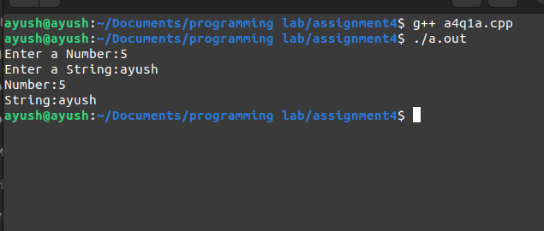
b)
PROGRAM:-
#include<bits/stdc++.h>
using namespace std;
namespace NMS1
{
int a;
void seta(int aa)
{
a=aa;
}
int geta()
{
return a;
}
}

namespace NMS2
{
string b;
void setb(string bb)
{
b=bb;
}
string getb()
{
return b;
}
}
using namespace NMS1;
using namespace NMS2;
int main()
{
int a;
string b;
cout <<"Enter a Number:";
cin >>a;
seta(a);
cout<<"Enter a String:";
cin>>b;
setb(b);
cout<<"Number:"<<geta()<<"\nString:"<<getb()<<endl;
return 0;
}

OUTPUT:-
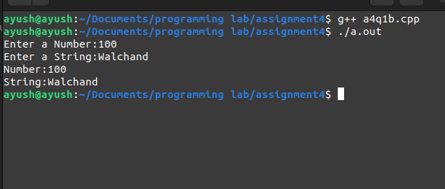

Q2. Create two namespaces as Outer and Inner, add any one variable, any one
function in both the namespaces.
Write a program to display members of both Outer and Inner namespace.
SOLUTION:-
PROGRAM:-
#include<bits/stdc++.h>
using namespace std;
namespace Inner
{
int a;
void seta(int aa){
a=aa;
}
int geta(){
return a;
}
}
namespace Outer
{
int a;
void seta(int aa){
a=aa;
}
int geta()
{
return a;
}
}
int main()
{
int a,b;
cout<<"Enter Number to be enter in first namespace:";
cin>>a;
Inner::seta(a);
cout<<"Enter Number to be enter in second namespace:";
cin>>b;
Outer::seta(b);
cout<<"Number in First namespace:"<<Inner::geta()<<"\nNumber in Second namespace:"<<Outer::geta()<<endl;
return 0;
}
OUTPUT:-
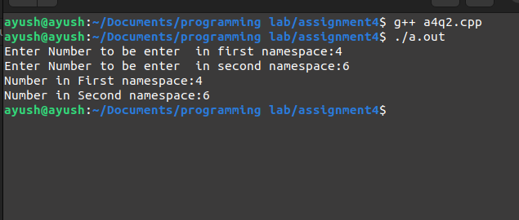
Q3. Create a class Employee in namespace Organization. Create functions as
setDetails (EmpID, Name, Salary) and getDetails ().
Write a program to call both the functions using object of Employee class.
SOLUTION:-
PROGRAM:-
#include<bits/stdc++.h>
using namespace std;
namespace operations
{
class employee{
public:
string name;
int id;
long long salary;
void setDetails(string n,int i,long long s){
name=n;
id=i;
salary=s;
}

void getDetails()
{
cout<<"Employee's Id:"<<id<<"\nName:"<<name<<endl;
cout<<"Salary:"<<salary<<endl;
}
};
}
using namespace operations;
int main()
{
int n;
cout<<"Enter No. of Employees:";
cin >>n;
employee e[n];
for(int i=0;i<n;i++)
{
int id;
string name;
long long salary;
cout<<"Enter Employee's Id:";
cin>>id;
cout<<"Enter Name:";
cin>>name;
cout<<"Enter Salary:";
cin>>salary;
e[i].setDetails(name,id,salary);
}
for(int i=0;i<n;i++)
{
cout<<"\n\nEmployee No."<<i+1<<":"<<endl;
e[i].getDetails();
}
return 0;
}

OUTPUT:-
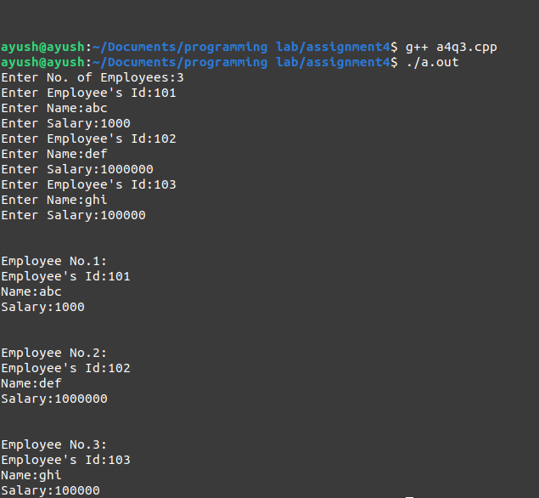

Q4. Write C++ Program to display largest among two numbers using function
templates.
SOLUTION:-
PROGRAM:-
#include<bits/stdc++.h>
using namespace std;
template <class C>void compare(C &a,C &b)
{
if (a<b)
{
cout<<a<<"<"<<b<<endl;
}
else if(a==b)
{
cout<<a<<"="<<b<<endl;
}
else
{
cout<<a<<">"<<b<<endl;
}
}
template <class C,class D>void compare(C &a,D &b)
{
if (a<b)
{
cout<<a<<"<"<<b<<endl;
}
else if(a==b)
{
cout<<a<<"="<<b<<endl;
}
else
{
cout<<a<<">"<<b<<endl;
}
}
int main()
{
int m=1,n=3,a=9;
float b=1.1,c=0.3,d=10.1;
compare(m,n);
compare(b,c);
compare(a,d);
return 0;
}
OUTPUT:-
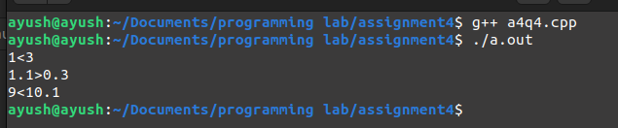
Q5. Write C++ Program to swap data using function templates.
SOLUTION:-
PROGRAM:-
#include<bits/stdc++.h>
using namespace std;
template <class t>void comp(t &a,t &b)
{
t c=a;
a=b;
b=c;
}
int main()
{
int a=1,b=2;
float m=1.1,n=1.2;
cout<<"Before:"<<a<<" "<<b<<endl;
cout<<"Before:"<<m<<" "<<n<<endl;
swap(a,b);
swap(m,n);
cout<<"After:"<<a<<" "<<b<<endl;
cout<<"After:"<<m<<" "<<n<<endl;
return 0;
}
OUTPUT:-
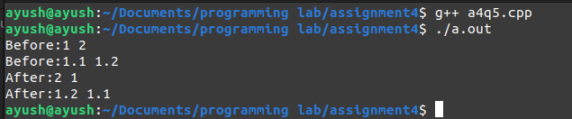
Q6. Write C++ Program which will demonstrate use of function template
overloading.
SOLUTION:-
PROGRAM:-
#include<bits/stdc++.h>
using namespace std;
template <class t> t mul(t a)
{
return a*a;
}
template<class t> t mul(t a,t b)
{
return a*b;
}
int main()
{
int a=11,b=12,c=14;
float d=1.1,e=1.2,f=1.4;
cout<<mul(a)<<"\n"<<mul(b,c)<<endl;
cout<<mul(d)<<"\n"<<mul(e,f)<<endl;
return 0;
}
OUTPUT:-
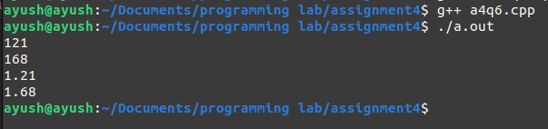

Q7. Write C++ Program using class template to perform searching operation on generic array.
SOLUTION:-
PROGRAM:-
#include<bits/stdc++.h>
using namespace std;
template <class t>t search(t a[5],t b)
{
for (int i = 0; i < 5; i += 1)
{
if (a[i]==b)
{
return i+1;
}
}
return -1;
}
int main()
{
int a[]={1,2,3,4,5};
float b[]={1.1,2.2,3.3,4.4,5.5};
cout<<search(a,4)<<"\n"<<endl;
cout<<search(a,8)<<"\n"<<endl;
cout<<search(b,(float)3.3)<<"\n"<<endl;
cout<<search(b,(float)8.1)<<"\n"<<endl;
return 0;
}
OUTPUT:-
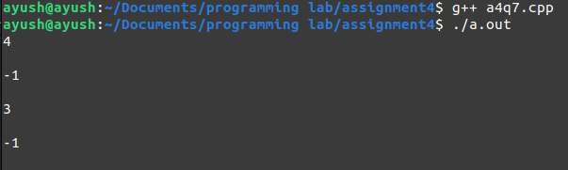

Q8. Write C++ Program to add, subtract, multiply and divide two numbers using
class template.
SOLUTION:-
PROGRAM:-
#include <iostream>
using namespace std;

template <class T>
class Calculator{
public:
T num1, num2;
Calculator(T n1, T n2){
num1 = n1;
num2 = n2;
}
void displayResult(){
cout << "Numbers are: " << num1 << " and " << num2 << "." << endl;
cout << "Addition is: " << add() << endl;
cout << "Subtraction is: " << subtract() << endl;
cout << "Product is: " << multiply() << endl;
cout << "Division is: " << divide() << endl;
}
T add(){
return num1 + num2;
}
T subtract(){
return num1 - num2;
}
T multiply(){
return num1 * num2;
}
T divide(){
return num1 / num2;
}
};
int main(){
int a,b;
cout<<"Enter two integers : ";
cin>>a>>b;
Calculator<int> intCalc(a,b);
float c,d;
cout<<"Enter two float numbers : ";
cin>>c>>d;
Calculator<float> floatCalc(c,d);

cout << "Integer results:" << endl;
intCalc.displayResult();

cout << endl << "Float results:" << endl;
floatCalc.displayResult();
return 0;
}
OUTPUT:-
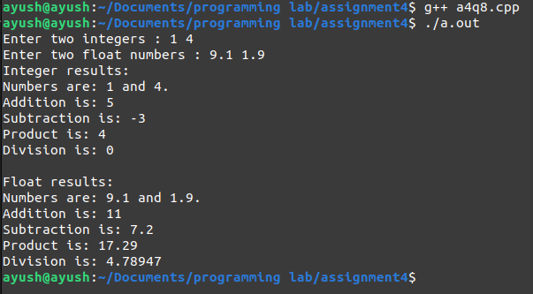
Q9. Write C++ Program for creating a class Numbers which has two generic type
variable x and y; create two objects NUM1 and NUM2 which will accept
integer and float type data types.
SOLUTION:-
PROGRAM:-
#include<bits/stdc++.h>
using namespace std;
template <class C,class D>void compare(C &a,D &b)
{
if (a<b)
{
cout<<a<<"<"<<b<<endl;
}
else if(a==b)
{
cout<<a<<"="<<b<<endl;
}
else
{
cout<<a<<">"<<b<<endl;
}
}
int main()
{
int a;
float b;
cout<<"Enter Integer:";
cin>>a;
cout<<"Enter Float value:";
cin>>b;
compare(a,b);
return 0;
}
OUTPUT:-
